E-COMMERCE MANAGEMENT SYSTEM

***Mini Project Report submitted by***

|  |
| --- |
| M KARTHIK  (4NM20CM017) |
| RANJITH B K  (4NM20CM033) |

***Under the Guidance of***

**Mr. Manjunatha A S**

Assistant Professor

*In partial fulfillment of the requirements for the award of*

*the Degree of*

**Bachelor of Engineering in Computer and Communication Engineering**

*from*

***Visvesvaraya Technological University, Belagavi***

Department of Computer and Communication Engineering

NMAM Institute of Technology, Nitte-574110

(An Autonomous Institution affiliated to VTU, Belagavi)

**JUNE 2022**



**ISO 9001:2015 Certified**

**Accredited with ‘A’ Grade by NAAC**

**DEPARTMENT OF COMPUTER AND COMMUNICATION ENGINEERING**

CERTIFICATE

*Certified that the mini project work entitled*

*“* .……………………………………………………………………….

………………………………………………………….. *”*

*is a bonafide work carried out by*

………………………………………..

*in partial fulfilment of the requirements for the award of*

***Bachelor of Engineering Degree in Computer and Communication* Engineering**

*prescribed b*y **Visvesvaraya Technological University, Belagavi**

*during the year* ***2021-2022****.*

*It is certified that all corrections/suggestions indicated for Internal Assessment have been incorporated in the report deposited in the departmental library.*

*The project report has been approved as it satisfies the academic requirements in respect of the mini project work prescribed for the Bachelor of Engineering Degree.*

**___________________ ___________________**

***Signature of the Guide Signature of the HOD***

Semester End Viva Voce Examination

Name of the Examiners Signature with Date

1. _______________________ _______________________

2. __________________________ __________________________

**ACKNOWLEDGEMENT**

We express our deep sense of gratitude to NMAM Institute of Technology that provided us an opportunity in fulfilling our most cherished desire of reaching the goal.

We are thankful to **Mr. Manjunatha A S**, staff in-charge who inspired us in our work and their support in carrying out this mini project.

We are also thankful to **Dr. Udaya Kumar Shenoy**, Professor & HOD, Department of Computer and Communication Engineering, who inspired us in our work and stood for many of our works.

We whole - heartedly express our gratitude to **Dr. Niranjan N Chiplunkar**, Principal, NMAMIT, Nitte who is responsible for creating such a pleasant environment and appreciating our talents in both academic and extracurricular activities.

We also thank both teaching and non-teaching staff of Department of Computer and Communication Engineering for their support in carrying out this project.

**M KARTHIK RANJITH B K**

**4NM20CM017**  **4NM20CM033**

**CONTENTS**

1.ABSTRACT

2.INTRODUCTION

3.LITERATURE SURVEY

4.PROBLEM DEFINITION

5.DETAILS OF THE PROJECT

6.RESULTS AND DISCUSSIONS

7.CONCLUSION

8.REFERENCES

1.ABSTRACT

The E-commerce Management System will primarily provide a platform to purchase, sell, distribution of items, product or service through the internet and on some other network. It will provide an option to a customer for the comparison of product with another seller, while a shop is available only at day time the e-commerce is available 24 hours of a day and seven days of the week.

The E-commerce Management System will be a huge marketplace as most of the business are going to implement based on the internet. This system will provide the detailed description of the products to users so that they can compare to the different product and will by the one which is more suitable to them.

This project is an attempt to provide the advantages of online shopping to customers of a real shop. It helps buying the products in the shop anywhere through internet by using an android device. Thus, the customer will get the service of online shopping and home delivery from his favourite shop.

This system can be implemented to any shop in the locality or to multinational branded shops having retail outlet chains. If shops are providing an online portal where their customers can enjoy easy shopping from anywhere, the shops won’t be losing any more customers to the trending online shops such as Flipkart or Ebay. Since the application is available in the Smartphone it is easily accessible and always available.

2.INTRODUCTION

This project is a web-based shopping system for an existing shop. The project objective is to deliver the online shopping application into android platform. Online shopping is the process whereby consumers directly buy goods or services from a seller in real-time, without an intermediary service, over the Internet. It is a form of electronic commerce. This project is an attempt to provide the advantages of online shopping to customers of a real shop. It helps buying the products in the shop anywhere through internet by using an android device. Thus, the customer will get the service of online shopping and home delivery from his favorite shop.

**2.1 PROJECT OBJECTIVE:**

The objective of the project is to make an application in android platform to purchase items in an existing shop. In order to build such an application complete web-support need to be provided. A complete and efficient web application which can provide the online shopping experience is the basic objective of the project. The web application can be implemented in the form of an android application with web view.

**2.2 PROJECT OVER VIEW:**

The central concept of the application is to allow the customer to shop virtually using the Internet and allow customers to buy the items and articles of their desire from the store. The information pertaining to the products are stores on an RDBMS at the server side (store). The Server process the customers and the items are shipped to the address submitted by them. The application was designed into two modules first is for the customers who wish to buy the articles. Second is for the storekeepers who maintains and updates the information pertaining to the articles and those of the customers. The end user of this product isa departmental store where the application is hosted on the web and the administrator maintains the database. The application which is deployed at the customer database, the details of the items are brought forward from the database for the customer view based on the selection through the menu and the database of all the products are updated at the end of each transaction. Data entry into the application can be done through various screens designed for various levels of users. Once the authorized personnel feed the relevant data into the system, several reports could be generated as per the security.

**2.3 PROJECT SCOPE:**

This system can be implemented to any shop in the locality or to multinational branded shops having retail outlet chains. The system recommends a facility to accept the orders 24*7 and a home delivery system which can make customers happy. If shops are providing an online portal where their customers can enjoy easy shopping from anywhere, the shops won’t be losing any more customers to the trending online shops such as Flipkart or Ebay. Since the application is available in the Smartphone it is easily accessible and always available.

3.LITERATURE SURVEY

**A. EXISTING SYSTEM**

Online buying behavior is affected by various factors like, economic factors, demographic factors, technical factors, social factors, cultural factors, psychological factors, marketing factors and legislative factors. Customers choose an online-shop mainly based on references, clarity terms of delivery, graphic design and additional services. Problematical customers read discussions on the Internet before they spend their money on-line and when customers are incapable to purchase the product fast and with no trouble they leave online-shop. Kotler (2003) described Consumer buying method as learning, information-processing and decision-making activity divided in several consequent steps: Problem identification, Information search, Alternatives evaluation, Purchasing decision, post-purchase behavior. Euthymia identified the main constituent of the online shopping experience as follows: the functionality of the Web site that includes the elements trade with the site’s usability. the emotional elements planned for lowering the customer’s hesitation by communicating trust and credibility of the online seller and Web site and the content elements including the aesthetic aspects of the online presentation and the marketing mix. Usability and trust are the issues more regularly found to influence the online consumer’s behavior. Karayiannis examined that discriminating of potential determinants between web- shoppers and non-shoppers. Free shipping is a great motivator to purchase the products and customers are willing to pay nominal charges for getting their products. While compare the shopping with others shopping, consumer stake product price and shipping charges almost equally into deliberation. There are some ways that retailers can do to improve the experience for their online shoppers. The first is to write the expected delivery date of the order, customers are willing to wait for their orders but want to know just how long that force is. Timely coming of product shipment encourages shoppers to recommend an online retailer. Consumers also want to track updates and delivery notifications to understand when their package is incoming. Online shoppers want flexibility in their shipping, mainly the ability to give special delivery instructions or schedule a delivery time. Customers are also wanting to gets the address changing option for filling the wrong address when they are purchasing online.

**B. PROPOSED SYSTEM**

The proposed system is based on a database system. This system provides facilities listed below:

1. Admin should login with valid username and password.

2. Admin manages customers and required details.

3. Admin can add, delete the customers and sellers.

4. Admin can view the details of the customers, products and sellers

5. Admin can remove the customers and his details.

6. Admin can remove the sellers and his details.

7. Customer should register and login with valid username and password

8. Customer can view and edit his details.

9. Customer can buy and view products.

10. Seller should register and login with valid username and password.

11. Seller can view, add and delete his products.

4. PROBLEM DEFINITION

Online shopping problems are great barrier to the online purchase aim of customers. General problems include prospect of having credit card. The obscurity to confirm their liability of the provide goods and the risk to buy a product that it would not value as much as customer pay for it. Aftersales problems, involved difficulty to change notworking product with a new one and products warranty are not assured. Online shopping has various disadvantages:

* The customers can not touch and feel the products when they want to purchase.
* Some time delivery time is so much late.
* Some time they will pay the shipping charges so why the cost of the product may increase.
* Lack of personal attention by the sellers. More chance to fraud.
* Security of internet banking password and credit card password.
* Lack of quality.

5. DETAILS OF THE PROJECT

**Available technologies:**

Languages: Django, HTML, CSS, JavaScript.

RDBMS: Database sqlite3.

Web server: Localhost

Development platform: Visual Studio Code.

**Tools used:**

Editor used: VS code.

Operating system: Windows 11.

**Hardware used**:

Processor: Intel core i5 11th gen.

Ram: 8 GB.

Hard disk: 512 GB.

**Features of Employee Management system**:

* Easy to use.
* It is completely secure.
* It is completely controlled by admin.
* This system is easily compatible with most of the web browsers.
* It is very interactive and saves time.
* Reduces paper works.
* Calculations are automated so it is highly accurate.
* Admin can view all the records whenever necessary with ease.

**Advantages:**

* Saves time and efforts. Customers do not have to stand in queues in cash counters to pay for the products that have been purchased by them. They can shop from their home or workplace and do not have to spend time travelling.
* The convenience of shopping at home. Generally, in physical stores, the sales representatives try to influence the buyers to buy the product. While in online shopping, you're free to do as you will.
* Wide variety/range of products are available.
* Good discounts / lower prices.
* Get detailed information about the product.
* We can compare various models/brands. There is a wide range of products online. The sellers display all the stuff they've got. This enables the buyers to choose from a variety of models after comparing the finish, features and price of the products on display.
* The e-commerce is open on 365 x 24 x 7. So, time does not act as a barrier, wherever the vendor and buyers are.

**E-R Diagram:** 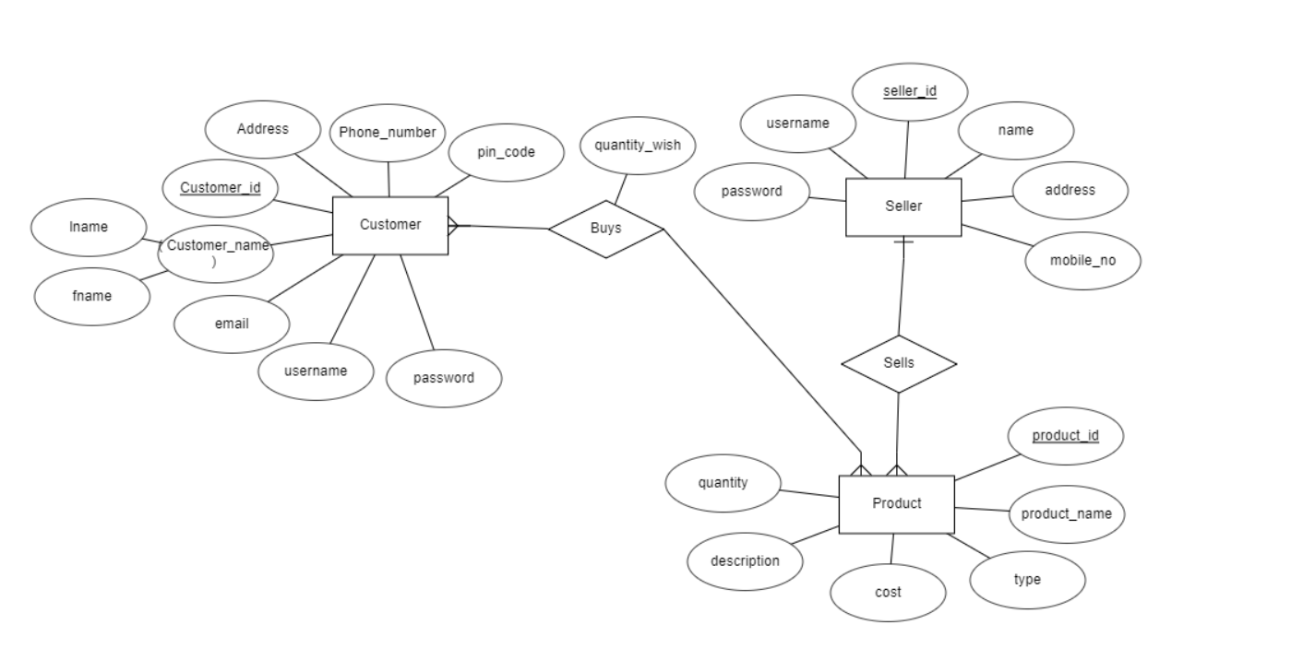

6. RESULTS AND DISCUSSIONS

Registration page for customer:

Registration page for seller:

Login page for customer:

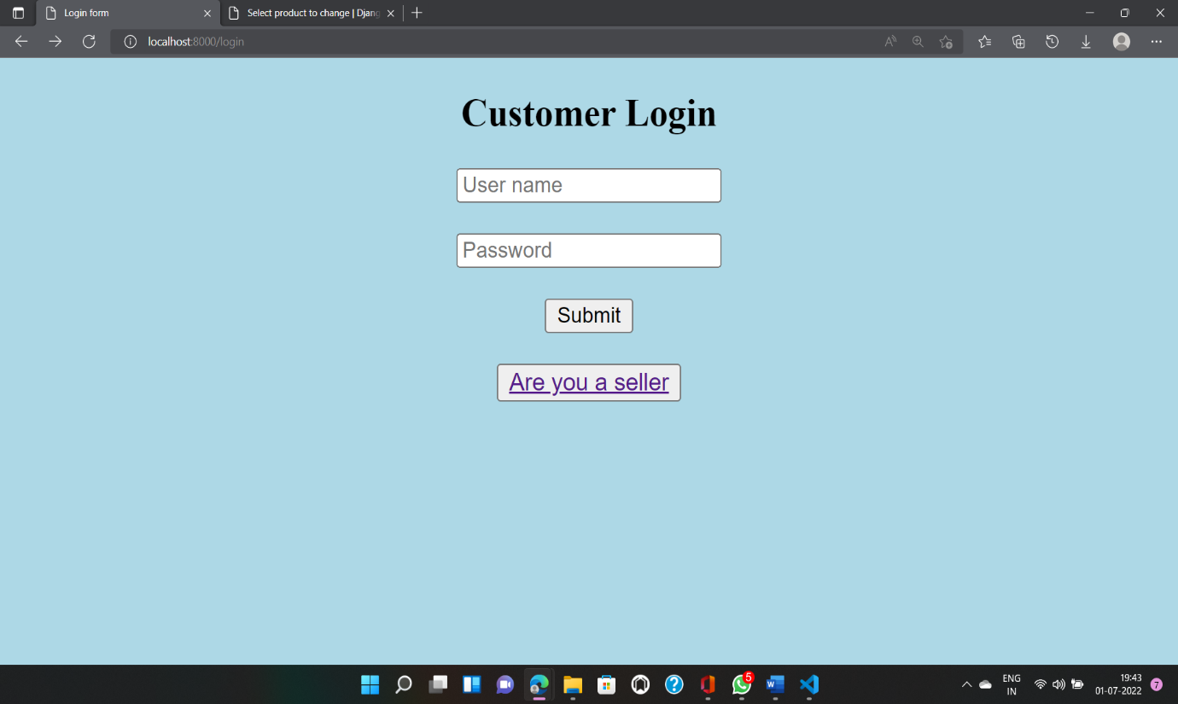

Login page for seller:

Admin home page:

**

Seller home page:

Search result:

Customer table:

Seller table:

Product table:

Sold-Product table:

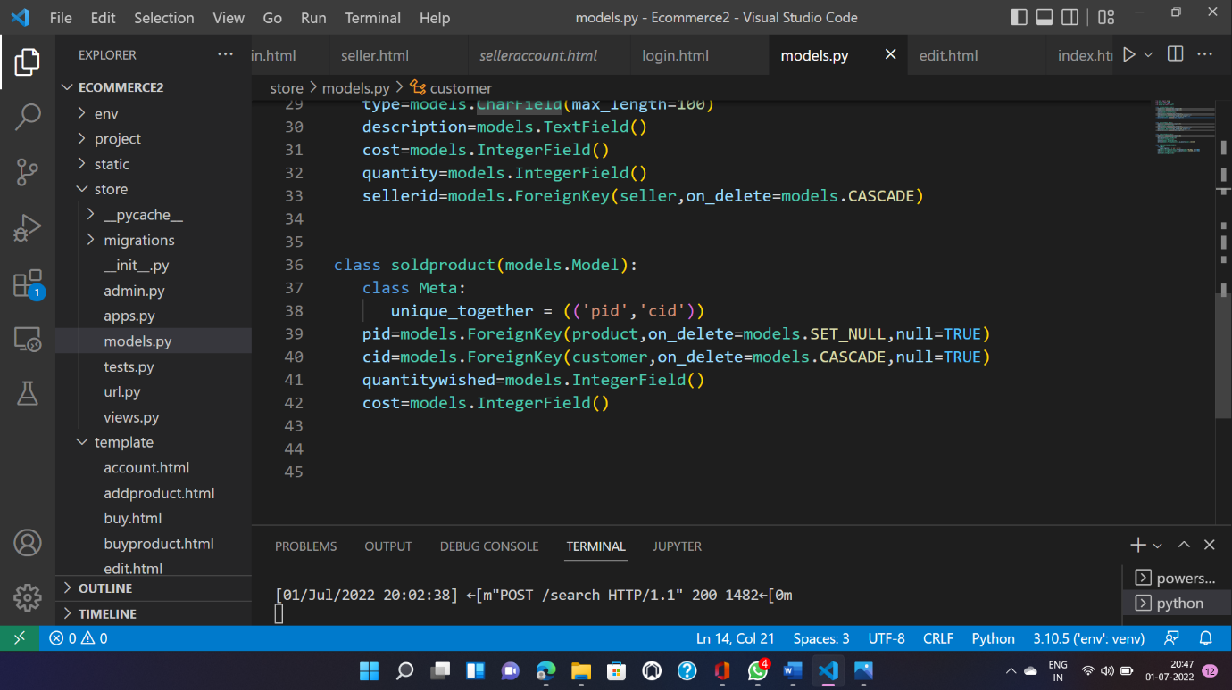

Sample code for seller home page:

<!DOCTYPE html>

<html lang="en">

<head>

<meta charset="UTF-8">

<meta http-equiv="X-UA-Compatible" content="IE=edge">

<meta name="viewport" content="width=device-width, initial-scale=1.0">

<title>Seller</title>

</head>

<body bgcolor="lightblue">

<center><h3><p style="color: blue;">{{user.name}}</p>Your products on Market<br><a href="selleraccount/{{user.id}}" align="right">profile</a></h3></center>

<p align="right">

<a href="sellerlogout">logout</a>

<br><br>

<a href="addproduct">add product</a>

<br><br>

</p>

<table align="center" width="100%" border="3"style="color:black;" bordercolor="green" style="border-style:double">

<tr>

<td><b><span>Product Name</span></b></td>

<td><b>Type</b></td>

<td><b>cost</b></td>

<td><b>Details</b></td>

<td><b>DELETE</b></td>

</tr>

{% for p in product %}

<tr>

<td>{{p.name}}</td>

<td>{{p.type}}</td>

<td>{{p.cost}}</td>

<td><a href="products/{{p.id}}">Details</a></td>

<td><a href="delete/{{p.id}}/{{user.id}}">delete</a></td>

</tr>

{% endfor %}

</table>

{% if msg %}

<h2>{{msg}}</h2>

{% endif %}

</body>

</html>

7. CONCLUSION

The project entitled Ecommerce management system was completed successfully. The system has been developed with much care and free of errors and at the same time it is efficient and less time consuming. The purpose of this project was to develop a web application for purchasing items from an online shop. This project enabled us to gain valuable information and practical knowledge on several topics like designing web pages using html & CSS, usage of responsive templates, designing of full stack Django application, and management of database using SQLite 3. The entire system is secured. Also, the project helped us to understand about the development phases of a project and software development life cycle. I learned how to test different features of a project. This project has given me great satisfaction in having designed an application which can be implemented to any nearby shops or branded shops selling various kinds of products by simple modifications. However, it was very challenging learning and developing an application using a new technology.

8. REFERENCES

<https://youtu.be/_ELCMngbM0E>

<https://github.com/sunitapt/dbms_online_shopping_ecommerce_system>